**Problem 1:**

#include <stdio.h>

#include <string.h>

int main() {

char sourceString[100];

char destinationString[100];

printf("Shadman Ahnaf ID: 23103065\n");

printf("Enter a string: ");

gets(sourceString);

strcpy(destinationString, sourceString);

printf("Copied String: ");

puts(destinationString);

*destinationString = '\0';

return 0;

}

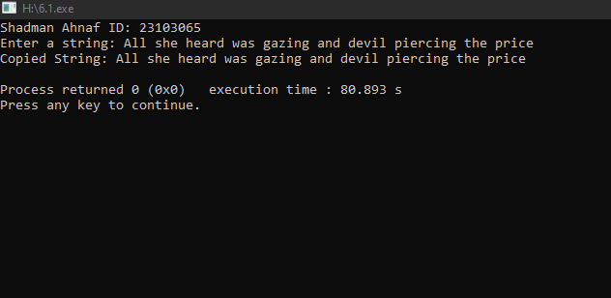

**Problem 2:**